2 MINUTES EXPLANATION
1️. Introduction (15–20 sec)
Hi, I’m Mickent Quenn Cuizon, a graduate of Bachelor of Science in Information Technology. I have experience in administrative work, lead generation, and medical records management. I’m skilled in Microsoft Office, basic graphic design using Photoshop and Canva, and basic web development, and I’m eager to continuously grow in the IT field.
2️. Hero / About Me (15 sec)
This is the hero section of my portfolio. Here you can see my profile picture and a brief introduction about me. I wanted to make it visually clean and professional to give a good first impression.
3️. Skills Section (15 sec)
Here I showcase my technical and soft skills, including Microsoft Office, basic web development, graphic design, and communication skills. These are the tools I’m most comfortable using in professional settings.
4️. Projects Section (30–40 sec)
In this section, I included projects I have worked on:
Portfolio Website – shows my skills in HTML, CSS, and design
Graphic Designs – created in Photoshop and Canva
Piso WiFi System project – a Geographical locations system for Piso WiFi is a project I worked on.
Each project highlights both my technical abilities and soft skills.
5️. CV Download & Contact (15 sec)
I also added a download CV button to make it easy to access my resume, and my contact information is clearly displayed here. This ensures anyone reviewing my portfolio can reach me quickly.”
6️. Coding & Animations (15 sec)
“If asked about coding:
I used HTML for structure, CSS for styling and animations, and JavaScript for simple effects like the typing animation in the hero section.
I may not be an expert yet, but I understand the basics and I’m continuously improving my skills.
7️. Closing (10–15 sec)
Overall, I built this portfolio to showcase my skills, experience, and projects. It reflects my motivation, attention to detail, and willingness to learn, which I bring to every professional opportunity.

90-Second Portfolio Script
Hi, I’m Mickent Quenn Cuizon, a graduate of Bachelor of Science in Information Technology. I have experience in administrative work, lead generation, and medical records management, and I’m skilled in Microsoft Office, basic graphic design, and basic web development.
This is my portfolio website, which I built to showcase my skills and projects. The hero section has my profile picture and a short introduction. The skills section highlights my main technical and soft skills.
In the projects section, I included three key works: my portfolio website, graphic designs I created in Photoshop and Canva, and a Piso WiFi system project with geographical locations of Piso WiFi. Each project demonstrates my abilities and attention to detail.
I also added a download CV button and my contact information for convenience. The website includes animations like a typing effect, which I built using HTML, CSS, and a small JavaScript snippet. I’m continuously learning to improve these skills.
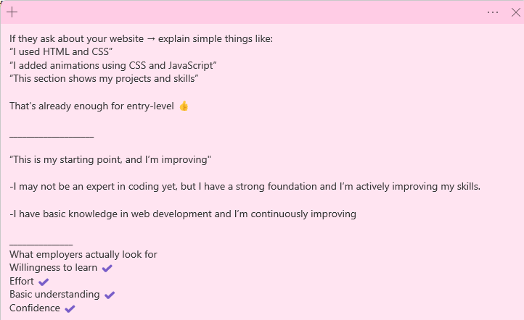
Overall, this portfolio reflects my motivation, attention to detail, and willingness to grow in the IT field, and I built it to give a clear picture of what I can contribute to a professional team.”

